First Name Last Name - Toby Huang

Email Address - toby.huang.757@gmail.com

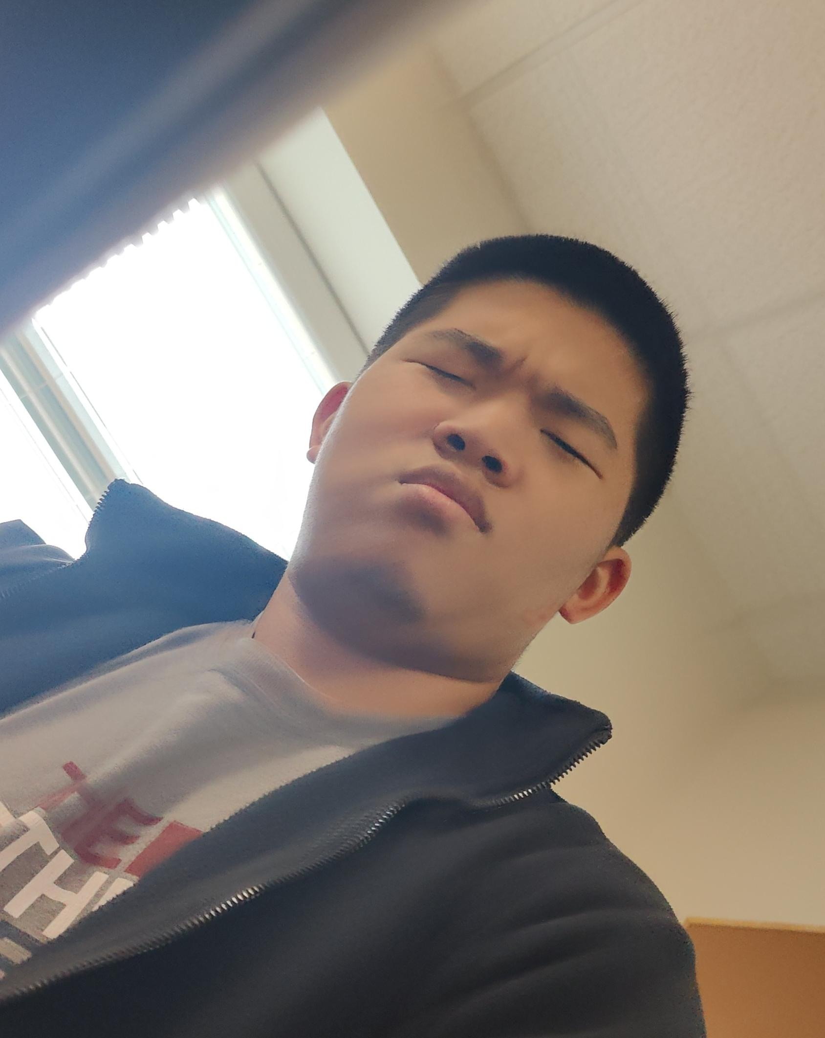

Grade - 11th

Where you plan to go to college/work - Reach schools = all the ivy leagues such as MIT. Realistically UT Austin/UTD in computer science. The specific field of computer science I want to go into hasn't really been decided. Dabbling into a little bit of everything for now.

What did you do this year - This year I mainly worked a bunch of UI aspects. I started with the death screen which is just a simple animation that plays on death with a fade and some cool graphics. The next thing I began to work on was the inventory but some complications forced me off the inventory system and I started to work on the settings. The settings system that I worked on has three more submenus that controll different aspects of the game settings. The first one I worked on was the graphics settings. In the graphics settings, the user can modify their graphics to whatever they would like and also have the option to simply get the best settings for their computer. The settings will save even if you close the game. The next settings menu I worked on was the audio system which is just a standard audio menu where you can save, reset, and change your volume settings for SFX, BGM, and master. The next/last thing I worke don was the keybinds menu. In the keybinds menu you can select a key to change your binds to and if that key isn't already taken, then it will change the bind to that key. Other than that it has your typical keybinds menu feel and will save your keybinds even if you close the game.